15 people are on a yacht. The yacht has developed a leak and is sinking fast. There is only one lifeboat and it will accommodate only nine people – not one more can fit and there are no more life boats or life jackets.

Which 9 people get to go in the lifeboat and be saved?

List the 9 chosen people in order of importance – because if you run out of food and water the “less important people” will have to be dumped overboard.
Priest
Grade School Teacher
Expecting Mother
Human Resources Professional
Lawyer
Firefighter
Doctor
Convicted Felon
Elderly Couple
Famous Artist
Veteran
Recovering Drug/Alcohol Addict
Teenager
Blind Man


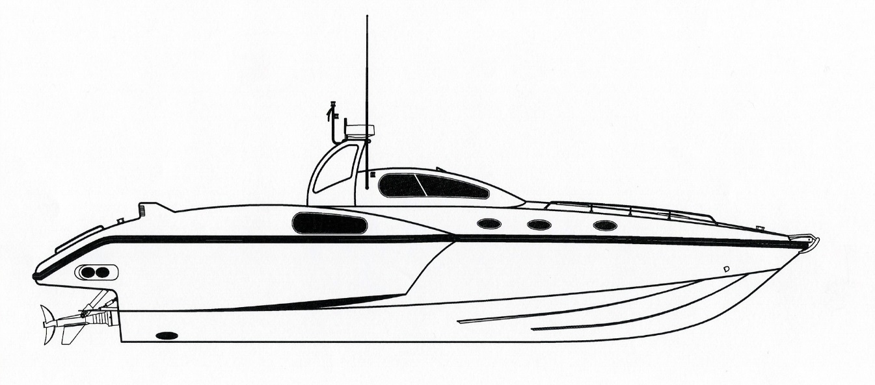

People Saved
(In Rank by Most Important to Least Important)

6. ________________________________________________
7. ________________________________________________
8. ________________________________________________
9. ________________________________________________

1. ________________________________________________
2. ________________________________________________
3. ________________________________________________
4. ________________________________________________
5. ________________________________________________

